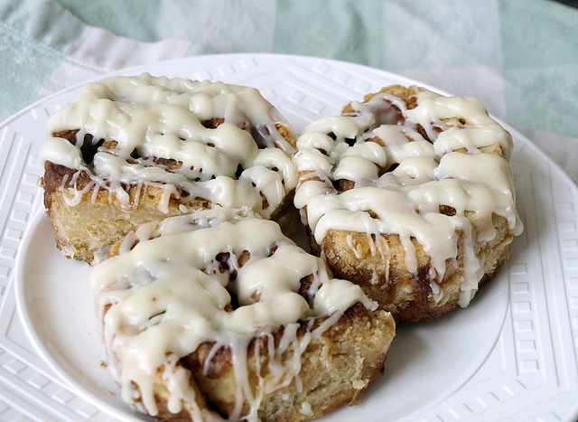

Cook Time: 20 minutes
Yield: 8-10 Cinnamon Rolls
Serving Size: 8-10
Ingredients
- 3/4 cup brown rice flour
- 1 cup potato starch
- 1 cup tapioca starch
- 1/4 cup millet flour
- 2 teaspoons xanthan gum
- 2 teaspoons baking powder
- 3/4 teaspoon baking soda
- 3 Tablespoons dark-brown sugar
- 1 teaspoon vanilla
- 3/4 cup melted organic shortening, divided
- 1 1/4 cup non-dairy milk (such as almond)
- 1/4 cup tapioca flour/sugar mix for rolling
- Oil, for pan
Filling
- 3/4 cup packed dark-brown sugar
- 1/4 cup sugar or raw sugar
- 2 teaspoons cinnamon
- 1 pinch salt
- 1 tablespoon dairy-free shortening
Icing - (Double if you like a lot)
- 2 Tablespoons melted organic shortening
- 2-4+ teaspoons non-dairy milk
- 3/4-1+ cups confectioners sugar
- Splash of vanilla extract (optional)

Cooking Directions
- Preheat oven to 400F.
- Oil a 9-inch round cake pan.
- Make the dough: In a mixing bowl, combine the dry ingredients. Stir in the vanilla, 1/2 cup of the melted shortening, and the non-dairy milk. Mix with a wooden spoon until dough looks shaggy. Knead the dough a bit with your hands until it comes together in a ball. Let stand for a few minutes to thicken.
- Make the filling: combine the ingredients in a small bowl. Taste and add more cinnamon, if desired. Set aside.
- Flatten the dough: Turn the dough onto a large piece of floured parchment. The dough should be moist; if it seems sticky, add some flour before rolling. Gently roll the dough into a rectangle, approximately 9 x 12 inches.
- Apply the filling: Brush the surface with half the remaining melted shortening. Evenly distribute the filling mixture over the dough, leaving a 1/2-inch border on all edges. Press the filling into the dough.
- Form the dough into a log: Start at the long side of the paper, then curl the dough together, using the paper and your hands to guide it into a cylindrical shape. Pinch the seam to seal in the final turn. Turn the dough so the seam side is up.
- Section the log: Using a sharp knife, slice the dough into 8 to 10 pieces. Place each piece into the prepared pan, then brush with the remaining melted shortening.
- Bake for 22 to 24 minutes: Until tops are lightly golden and filling is bubbling.
- Cool in pan for 10 minutes. Use a spatula to remove each roll individually. Transfer to a cooling rack.
- Make the icing: Combine the ingredients in a bowl until smooth, adding additional non-dairy milk for desired consistency. (If icing gets too thin, add more confectioner's sugar.) Pour, drizzle, or pipe the glaze over the rolls.
- Serve warm. Store rolls in an airtight container for up to 3 days. Reheat to serve.

